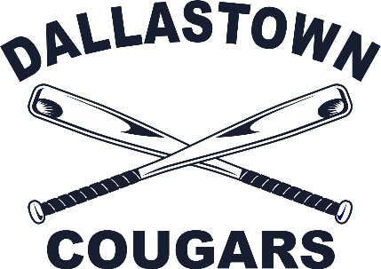
DALLASTOWN COUGAR LITTLE LEAGUE
YEARBOOK SPONSORSHIP APPLICATION
Local business partner,
Thank you for your interest in supporting Dallastown Cougar Little League for the upcoming season. Each spring, Dallastown Cougar Little League Baseball publishes an annual yearbook, and to support the publication of that yearbook (and other league functions) we solicit advertising partnerships with local businesses.
Our annual yearbook consists of a photo directory of all teams, information on Dallastown Cougar Little League, shout-outs from family and friends to the players, and advertisements to promote our local business partners.
Don’t miss this chance to get your spot in the yearbook!
The cost schedule for 2025 ads is as follows:
(Possible addition - $5 Shout outs)
Fee | Ad Size
$20 | Business Card
$40 | ¼ Page
$80 | ½ Page
$160 | Full Page

If you are interested in partnering with us for the upcoming publication, please fill out the yearbook sponsorship agreement section below. Please send all desired ad graphics to yearbook coordinator Amanda Brimfield (amandabrimfield@gmail.com). Thank you for your consideration!
Sponsor Information:
Company name: ___________________________________________________________
Contact Person: ____________________________________________________________
Address: __________________________________________________________________
City: _________________________________ State ________ Zip ________________
Phone: _________________________________ Email _______________________________________
Desired Ad Size: _____________________________________________________________________
Authorized Signature: ________________________________________________________________
Please make all checks payable to DCA. Payment may be sent to:
DCA / Attn: Wendy Neutzel / 1911 Ebony Dr. / York PA 17402

